Name - Dhanshree Soni

Capstone Project (SQL)
Analytical CRM Development for a Bank

Objective
You are an analytical CRM (Customer Relationship Management) specialist hired by a bank to extract meaningful insights from various customer-related datasets. The bank aims to reduce customer churn, improve service delivery, and enhance customer satisfaction. They have provided you with datasets including customer demographics, transaction details, customer exit information, and active customer profiles.

- Imported different Excel and CSV datasets into a single Excel workbook.
- Perform data cleaning to resolve inconsistencies and missing values
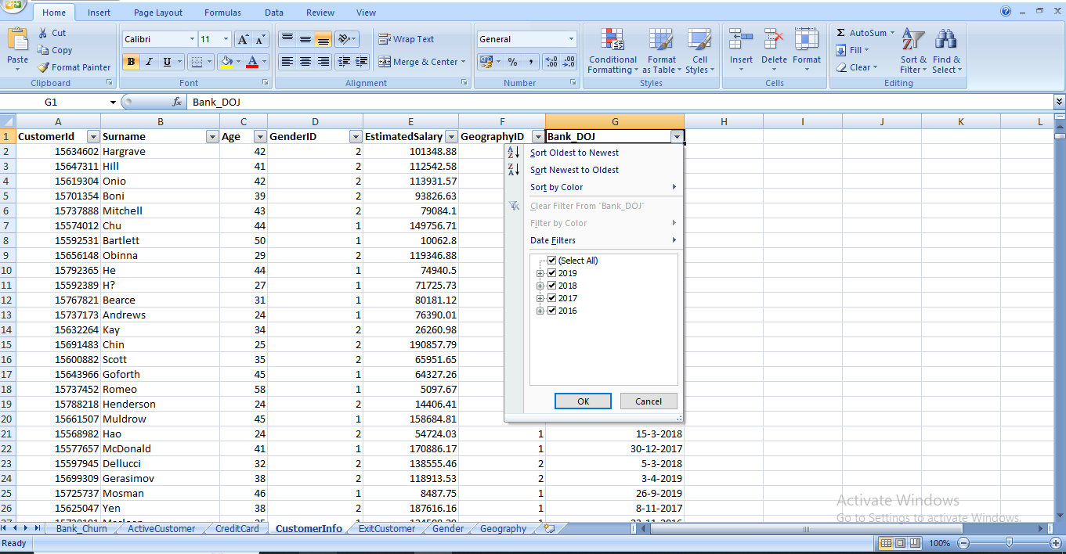
Ensured no missing values.

- Changed the data type of DOJ in Mysql Workbench as it was imported in string format
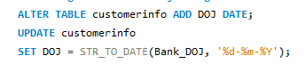
- Calculated expected churn date by adding Tenure with the year of DOJ
#calculating a date column in bank_churn using tenure and doj
Alter table bank_churn ADD churndate Date;
UPDATE bank_churn y
INNER JOIN customerinfo c
ON y.customerid = c.customerid
SET y.churndate = DATE_ADD(c.DOJ, INTERVAL y.Tenure YEAR);
- After calculating the expected churn date all the dates were of years 2022 and 2023
- Assuming the data for the year 2022 and 2023,customers who have exited are churned customers and who have not exited are loyal customers.

Objective Questions
- What is the distribution of account balance across different regions?
- Average distribution of account balance for all the geographic locations are
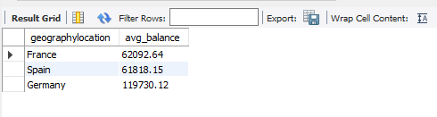

2. Identify the top 5 customers with the highest Estimated Salary in the last quarter of the year. (SQL)
Top 5 customers with highest estimated salary are
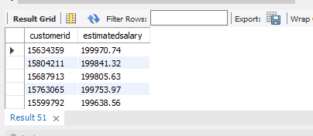

3.Calculate the average number of products used by customers who have a credit card. (SQL)
Average number of products used by customers who have credit cards is 1.
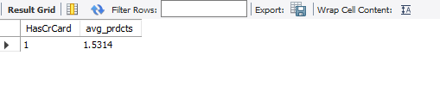
4.Determine the churn rate by gender for the most recent year in the dataset.
Churn rate for female customers are more than male customers
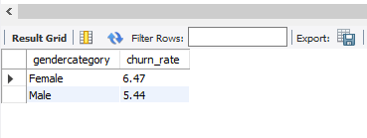
5. Compare the average credit score of customers who have exited and those who remain. (SQL)
Average credit score for the customers who have exited is slightly less than the retained customers.
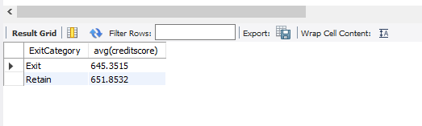
6. Which gender has a higher average estimated salary, and how does it relate to the number of active accounts? (SQL)
Female customers who are inactive members have a higher average estimated salary.
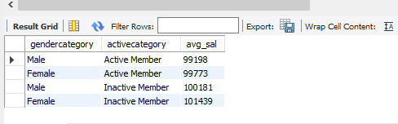

7. Segment the customers based on their credit score and identify the segment with the highest exit rate. (SQL)
Customers who have average credit scores are more prone to getting churned.
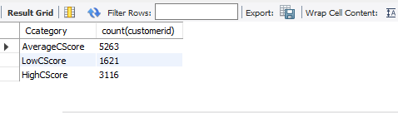

8. Find out which geographic region has the highest number of active customers with a tenure greater than 5 years. (SQL)
France has the highest number of active customers with tenure greater than 5 years.
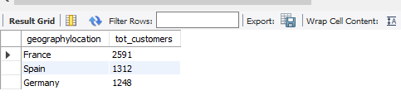
9. What is the impact of having a credit card on customer churn, based on the available data?
Customers who are credit card holders are more prone to getting churned.
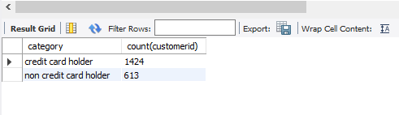

10. For customers who have exited, what is the most common number of products they have used?
The most common number of products they have used is 1.
Customers who were using a higher number of products were loyal to the bank.
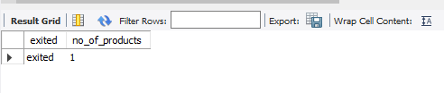

11. Examine the trend of customers joining over time and identify any seasonal patterns (yearly or monthly). Prepare the data through SQL and then visualize it.
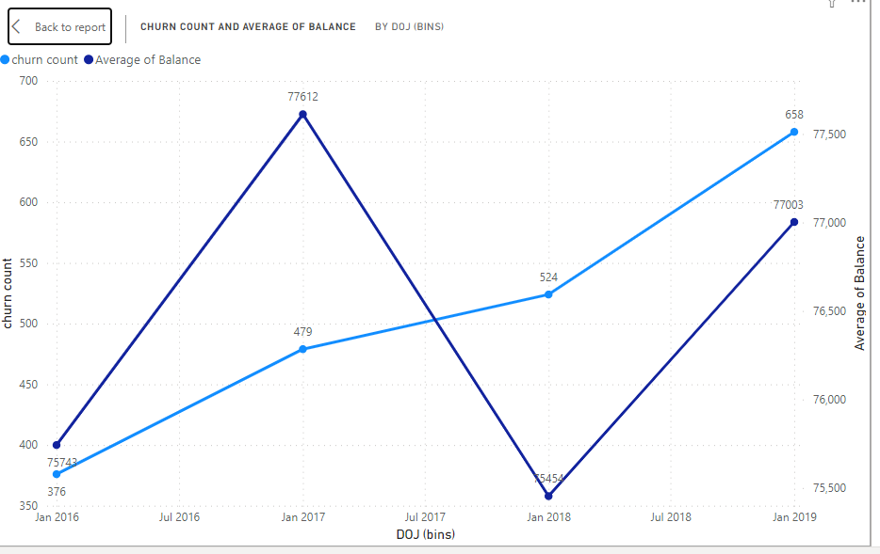
Customers joined in the year 2018 and 2019 have high churn rate.
Customers who joined in the year 2017 and 2019 have a high average balance.

12. Analyze the relationship between the number of products and the account balance for customers who have exited.
Customers who had 4 products had higher account balance,followed by customers who had 1 product and then 2 and 3 products.
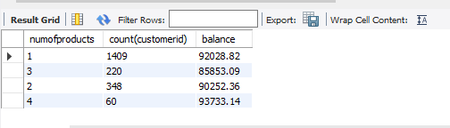

13. Identify any potential outliers in terms of balance among customers who have remained with the bank
Calculated the value for comparing with the balance of each customer to look for potential outliers.
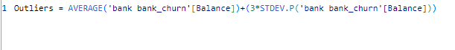
Counted rows whose balance is greater than the above value.
Certain that there were no customers with negative value so no balance lesser than zero.

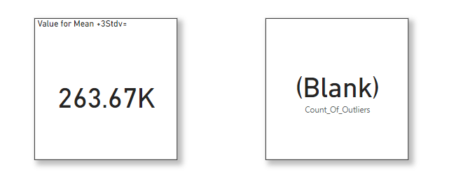
There are no outliers in the bank.
14. How many different tables are given in the dataset, out of these tables which table only consists of categorical variables?
There are a total 7 tables in the dataset,out of which 5 tables have categorical data which are active customer, credit card, exit customer,gender,geography.
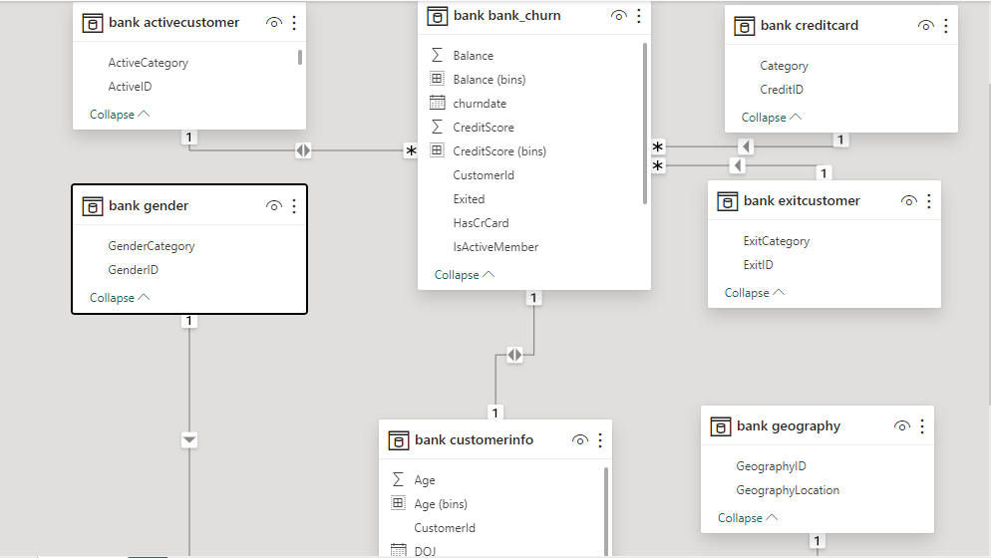

15. Using SQL, write a query to find out the gender-wise average income of males and females in each geography id. Also, rank the gender according to the average value. (SQL)
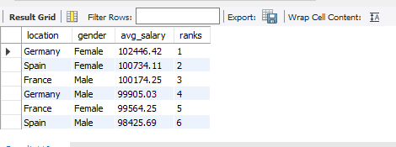

16. Using SQL, write a query to find out the average tenure of the people who have exited in each age bracket (18-30, 30-50, 50+).
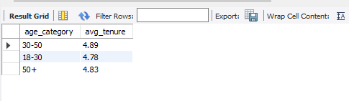

17. Is there any direct correlation between salary and the balance of the customers? And is it different for people who have exited or not?
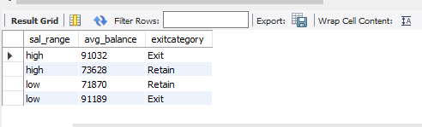

No, there is no direct correlation between salary and balance of the customer and it is no different for customers who have exited or retained.
18. Is there any correlation between the salary and the Credit score of customers?
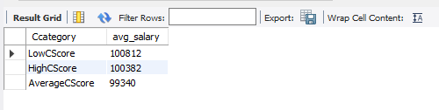
Assuming the bucket as follows
- 350-450 low credit score
- 451-600 Average credit score
- >600 High credit score

Customers with a high salary have a lower credit score ,average salary have a high credit score.
19. Rank each bucket of credit score as per the number of customers who have churned the bank.
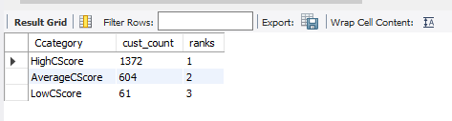
Assuming the bucket as follows
- 350-450 low credit score
- 451-600 Average credit score
- >600 High credit score
There are more customers who have high credit scores.

20. According to the age buckets find the number of customers who have a credit card. Also retrieve those buckets that have lesser than average number of credit cards per bucket.
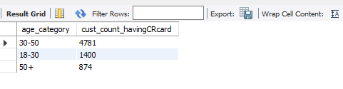
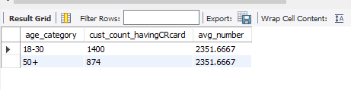

21. Rank the Locations as per the number of people who have churned the bank and average balance of the customers.
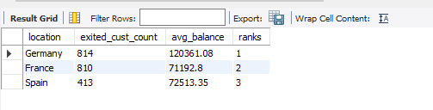

22. As we can see that the “CustomerInfo” table has the CustomerID and Surname, now if we have to join it with a table where the primary key is also a combination of CustomerID and Surname, come up with a column where the format is “CustomerID_Surname”.
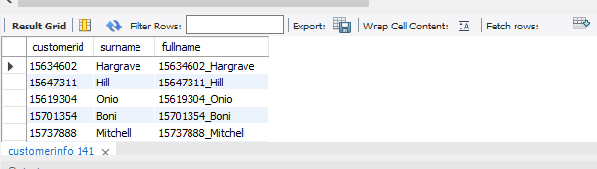

23. Without using “Join”, can we get the “ExitCategory” from ExitCustomers table to Bank_Churn table? If yes do this using SQL.
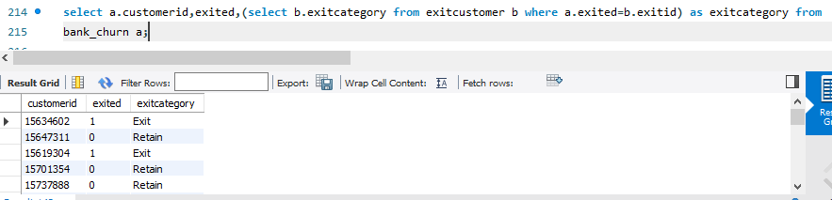
24. Were there any missing values in the data, using which tool did you replace them and what are the ways to handle them?
No, there were no missing values in the data.This was checked in the excel and powerbi applications by applying filters in excel and checking column quality in powerbi.

25. Write the query to get the customer IDs, their last name, and whether they are active or not for the customers whose surname ends with “on”.
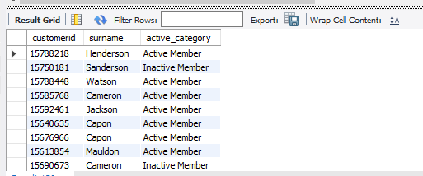

Subjective Question:

- Customer Behavior Analysis: What patterns can be observed in the spending habits of long-term customers compared to new customers, and what might these patterns suggest about customer loyalty?
- Created a measure for calculating percentage of amount spent from total amount.
- The percentage of the amount spent decreases from the year 2018 to 2019,increases from 2016 to 2017 and remains approximately the same from 2017 to 2018.
- There was a gradual increase in churn percentage for all the year.
- There is no defined relationship between spending habits and customer loyalty.
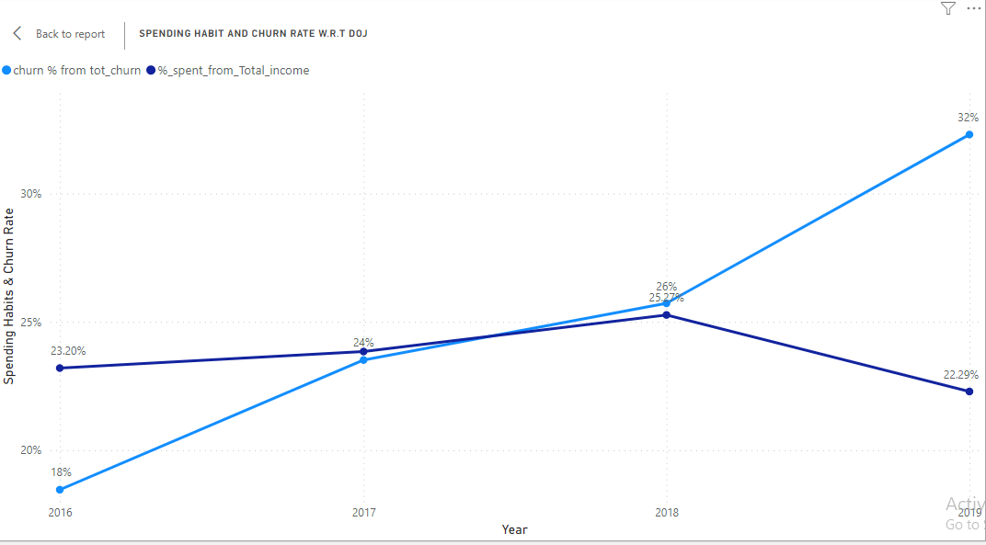

Q2. .Product Affinity Study: Which bank products or services are most commonly used together, and how might this influence cross-selling strategies?
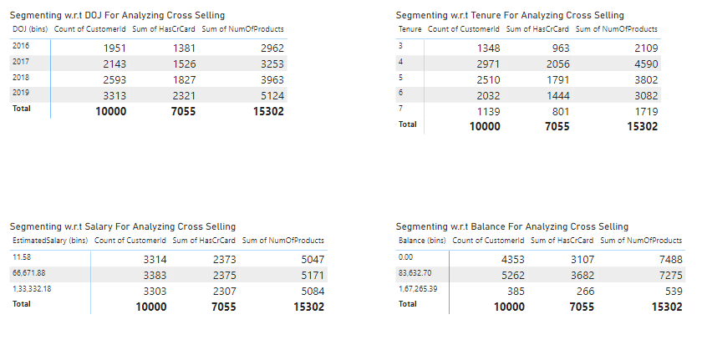

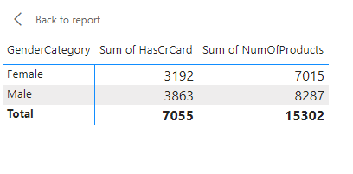
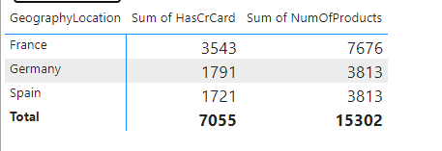

- There is no proper information with respect to the services so accuracy might be altered.
- From the above chart we can gain insight that for the customer segment who have credit cards, the number of services purchased for them are doubled.
- According to geographic location France has a higher number of credit card sales,w.r.t gender Male use more credit cards
- Customers who have joined the bank recently i.e new customers are having more credit cards and hence the cross selling is also more.
- Also we can observe that customers who have low to medium balance in their accounts tend to purchase credit cards.
- Conclusion-The reason for customers who cannot save money or have low balance to buy credit cards is certain that credit cards provide the amount in credit but the customers who have good savings habits or who earn more might not find any impacting result to purchase credit cards and hence cross selling also decreases.

Q3. Geographic Market Trends: How do economic indicators in different geographic regions correlate with the number of active accounts and customer churn rates?
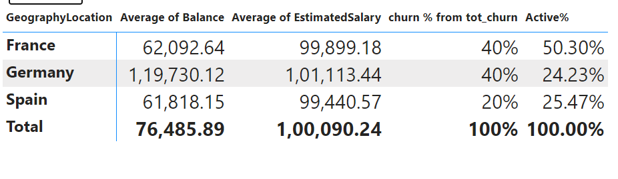
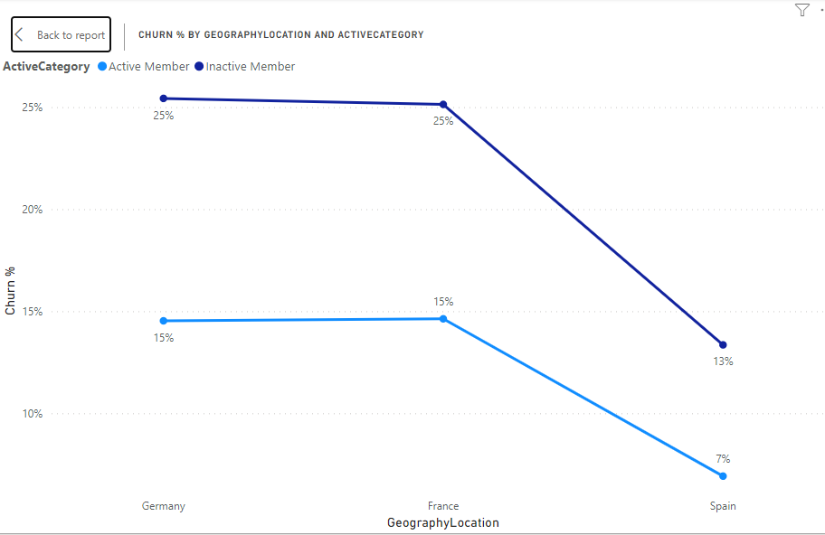

- Created two measure for calculating total active customer and total churn customer
- Created another two measure for calculating % of churn and Isactive
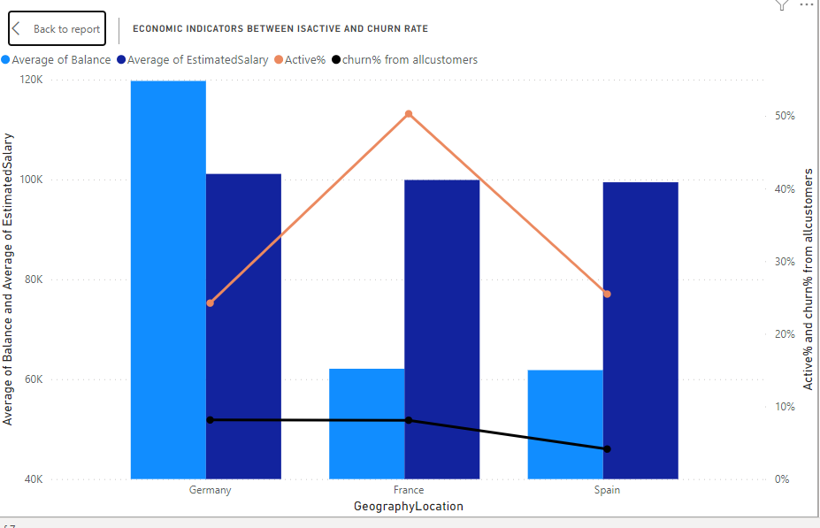
- As we can see from the above matrix table there is no direct relationship between the economies of different geographic regions and Churn and Active%.
- Churn % for France and Germany are more whereas for Spain it is less.
- More active customers are in France than in Spain and Germany.
- From the line graph for churn percentage by geography and active category we can find out a direct relationship between churn and activity of the customer.If the customer is inactive then the churn % is more and vice versa.

Q4. Risk Management Assessment: Based on customer profiles, which demographic segments appear to pose the highest financial risk to the bank, and why?
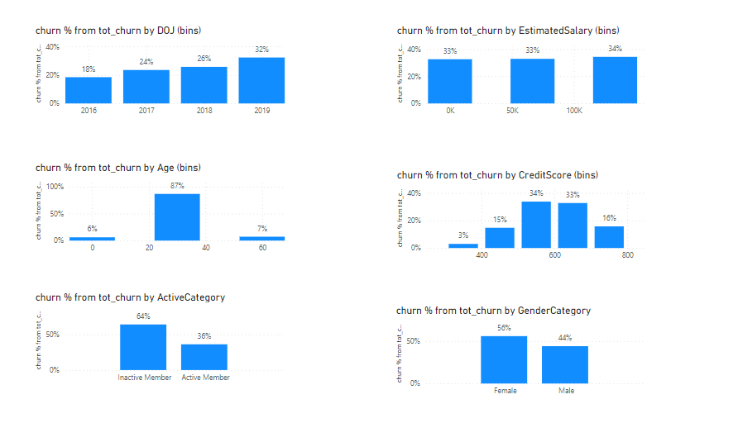
- From the above visualization we can analyze that customers who joined in the year 2019,who are in the age 20-40,who have average credit score,and are inactive have more probability to get churned.
- The highest biased category is age and inactive members.
- If the churned rate increases then banks will have reduced revenue generated,less loan opportunities and reduced cross selling potential which can be a high financial risk.

Q5. Customer Tenure Value Forecast: How would you use the available data to model and predict the lifetime (tenure) value in the bank of different customer segments?
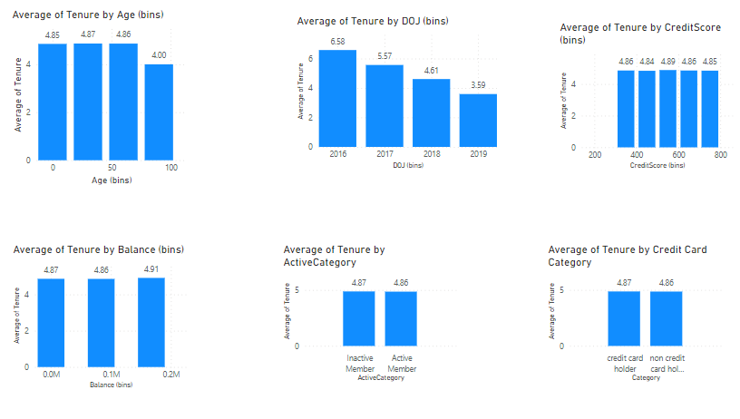
- Analyzed average of tenure on the basis of different customer segments.
- There are visible difference in the average tenure value only from two demographics.All the other segments have minor to no significance difference
- Customers who are greater than 60 years old tend to have less tenure.
- Customers who joined recently i.e either in 2019 or 2018 have a low tenure period.
- Q6. Marketing Campaign Effectiveness: How could you assess the impact of marketing campaigns on customer retention and acquisition within the dataset? What extra information would you need to solve this?
Impact of marketing campaigns cannot be calculated without the data related to different marketing campaigns.
The analysis would still be possible only if the time of conducting marketing campaigns were given.Number of churn% for that particular period w.r.t other time periods would have given insights on the effectiveness.
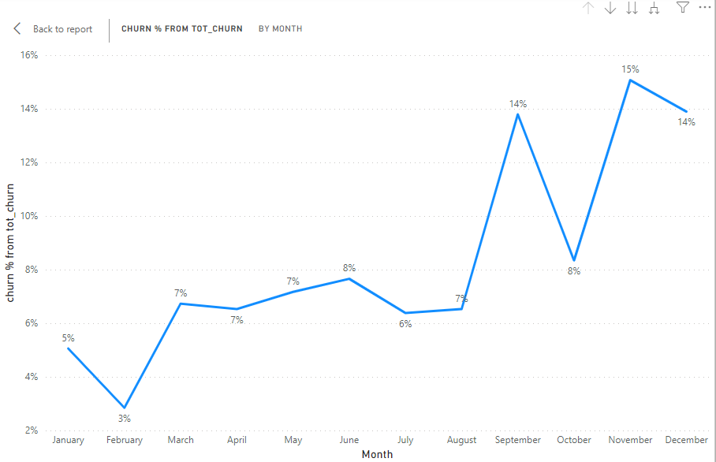

If we plot a line chart on churn rate with respect to the months of year then we can see the following patterns.
There is a 50% drop in the churn rates from the months of January to February and September to October.
Assuming that marketing campaigns were run during February and September then this was 50% effective.

Q7. Customer Exit Reasons Exploration: Can you identify common characteristics or trends among customers who have exited that could explain their reasons for leaving?
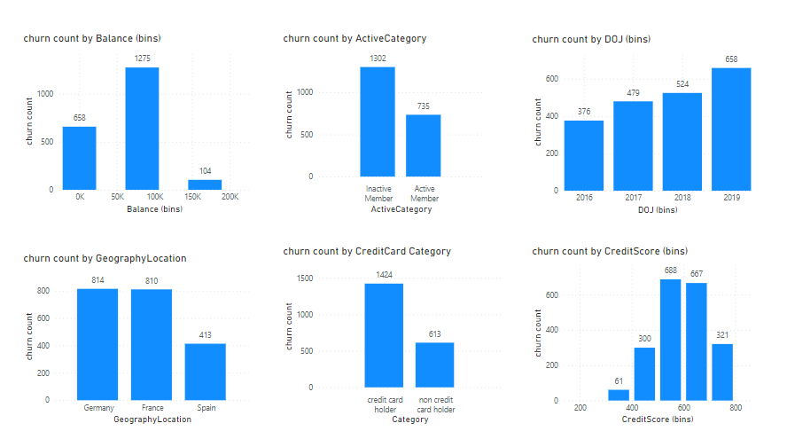
Analyzing churn count by different segments,from the above graph we can observe that
- Customers residing in Germany or France
- Customers who joined bank recently
- Customers who are inactive
- Customers who is a credit card holder
- Customers who have an average credit score and balance tend to have a high churn rate.

Q8. Are 'Tenure', 'NumOfProducts', 'IsActiveMember', and 'EstimatedSalary' important for predicting if a customer will leave the bank?
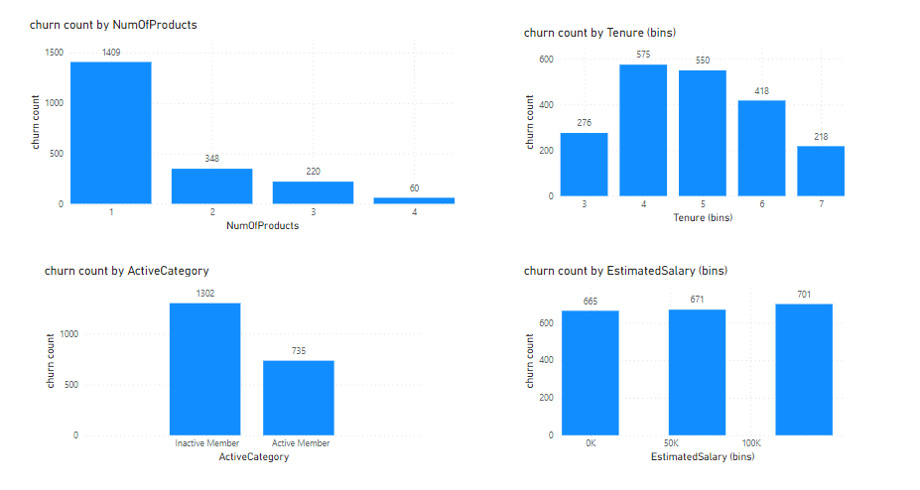
- From the visualization we can observe that Number of Products has a significant role in predicting whether the customer will churn.
- Active Category has high significance in deciding churn factor.
- Estimated Salary does not have any significance.
- Tenure will have average significance as the difference is not very high from all the bins.

Q9. Utilize SQL queries to segment customers based on demographics and account details.
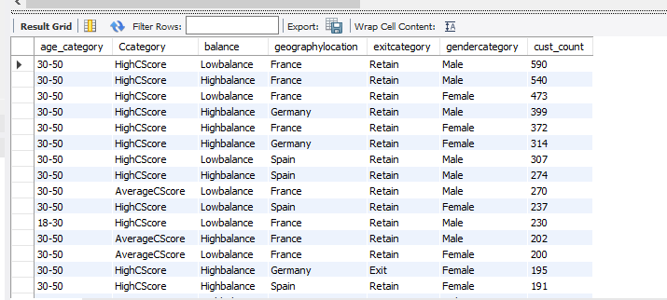

Q10. How can we create a conditional formatting setup to visually highlight customers at risk of churn and to evaluate the impact of credit card rewards on customer retention?

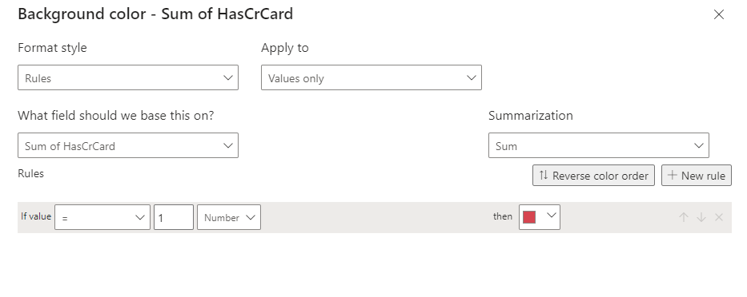
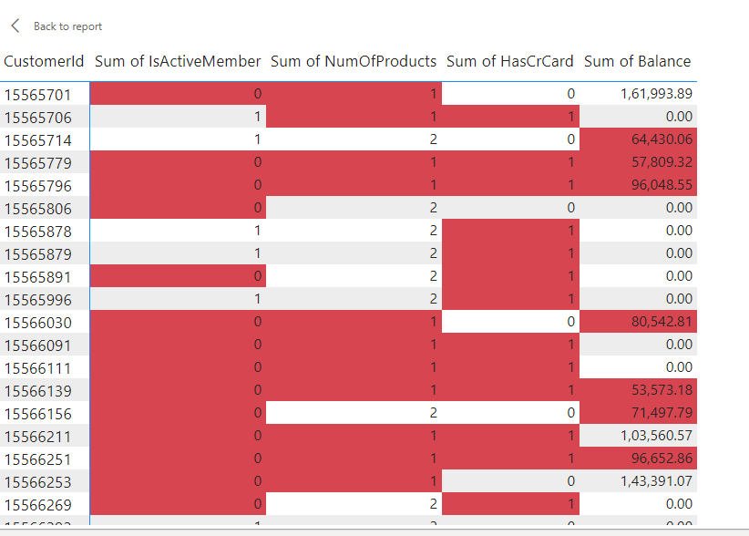
- Taking into consideration Non-Active members,Number of products,Credit Cards,Average balance amount we can use conditional formatting in each column to highlight the customer who has high risk of getting churn.
- If all the 4 columns are red then the probability of customer getting churned is high.The probability decreases as the highlighted cell decreases for a particular column.
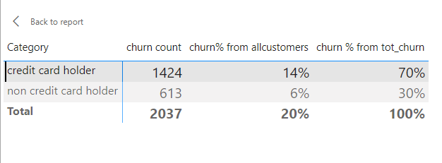
- Customers who are credit card holders have a higher churn rate than non credit card holders as seen in the above matrix table.
- If the bank will start giving rewards to credit card users then certainly the churn rate will decrease.
- The sale for Credit Cards will increase as customers get really fascinated with rewards and hence the total revenue will also increase with more cross selling.

Q11. What is the current churn rate per year and overall as well in the bank? Can you suggest some insights to the bank about which kind of customers are more likely to churn and what different strategies can be used to decrease the churn rate?
Overall churn rate is 20% for both the years
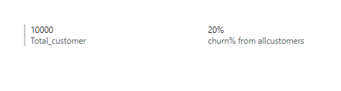

Churn rate for 2022 is 8% and for the year 2023 is 12%.
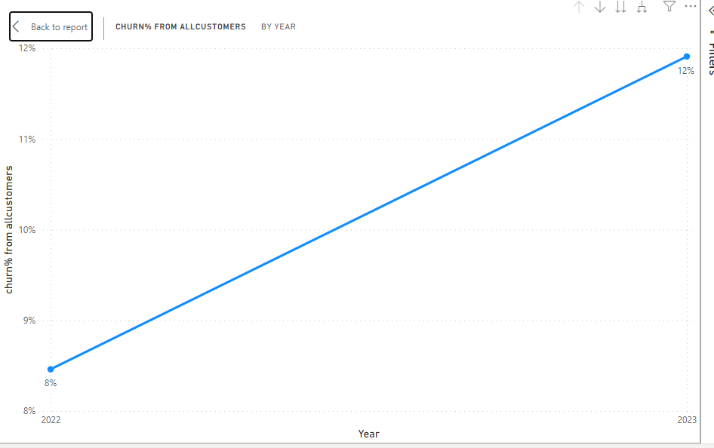
- There was an increase in churn rate
Customers who are more likely to churn can be
- Customers from Germany or France
- Customers who are inactive
- Customers who has less number of products
- Customers who joined the bank recently i.e either in year 2019 or 2018
To overcome this
- Banks should add credit rewards to credit card holders.
- Should try running different marketing campaigns
- Should try to educate customers with their products and benefits and saving money
- Should convert inactive users to active users by initially giving them extra benefits(Such as low interest rate,few installments by the banks for any policy etc…)
- Promotional offers every year for the customer loyalty/Birthday greetings or flowers for customer relationships..
- Should take feedback from the customers joined in the latest years i.e 2018 and 2019 as their churn rate is high and try to improve them.
- Increase cross selling and up selling of the products,we can observe that customers who were having more products had lower churn rate which is very valid.
- Churn rate in Germany and France are high compared to Spain.Managers should analyze the process and try to learn new strategies or find segments which are not to the par with Spain and rectify it.

Q12. Create a dashboard incorporating all the KPIs and visualization-related metrics. Use a slicer in order to assist in selection in the dashboard.
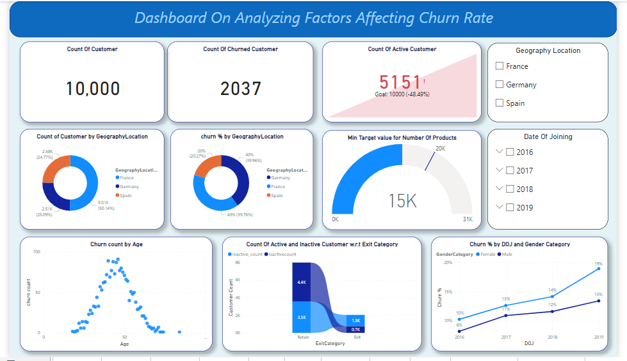
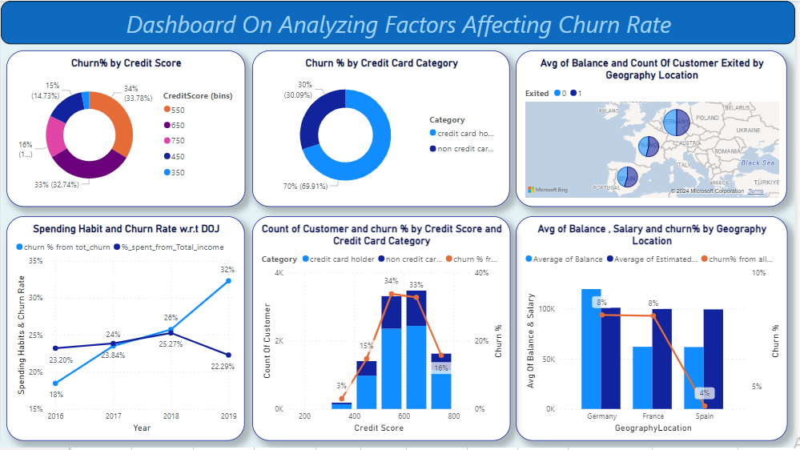

Q13. How would you approach this problem, if the objective and subjective questions weren't given?
If the objective and subjective questions were not given then I would have visualized the data using different segments in power bi using various charts.
Then I would have tried to identify the problem statement by visualizing the variations or differences.
Would come up with solutions to minimize the variations.

Q14. In the “Bank_Churn” table how can you modify the name of the “HasCrCard” column to “Has_creditcard”?
Using SQL
Alter table bank_churn
Rename column HasCrCard to Has_creditcard
Or
Using Power BI
Power Query->Select the column name->Right click->Rename->Type Has_creditcard.

